Name of Department Conduction Training: ___________________________________________
Address of Department: __________________________________________________________
Location of Training: _____________________________________________________________
County of Training: ____________ Date of Training: ____________ Time of Training: _________
Lead Instructor: _________________________ Contact Number: ________________________
List all other instructors that will be assisting in this training: 1. __________________________
2. ________________________ 3. ________________________ 4. _______________________
5. ________________________ 6. ________________________ 7. _______________________
8. ________________________ 9. ________________________ 10. ______________________
Each Department Shall Maintain Copies of the following Documentation:
- Copies of all paperwork submitted to the Kentucky Division of Air Quality (if required)
- A detailed lesson plan of the training that will be conducted
- Copy of permission forms to participate in the training that will be conducted
- Copy of proof of a clear title (in required)
- Copy of Certificate of Cancellation of Insurance on the structure (if required)
- Site plan drawing of the burn site (if required)
- Floor plan drawing of the burn site detailing all rooms, hallways, and exterior openings (if required)
- Asbestos abatement and inspection clearance (if required)
By signing this application, I attest to the best of my knowledge that NFPA 1403 is followed during this live fire training exercise.
________________________________ ____________________________________
Lead Instructor Date Fire Chief or Designee Date
_______________________________________________ ______________________________________________________
Fire Commission Designee Date ^{Regional Training Coordinator} ^{Date}
Submit all applications to the following: Commission on Fire Protection Personnel Standards and Education Attention Marc Rudder or Ericka Cole 118 James Court, Lexington, KY 40505
KYFC Form Version: September 2019
OCFIA Version: August 2020

Permits, Documents, Notifications, Insurance
- Secure the following written documentation from the owner:
  - Permission to burn structure – N/A
  - Proof of clear title – Property of Oldham County Fire Instructors Association (OCFIA)
  - Certificate of insurance cancellation – N/A
  - Acknowledgement of post-burn property condition – N/A
  - Debris removal is the responsibility of the property owner – N/A
- Obtain the following:
  - Local burn permit – Yes approved by AHJ
  - Permission to utilize fire hydrants – Yes, letter from Oldham County Water Company attached and kept on file with OCFIA
  - Authority to block off roads – N/A training taking place off the roadway at OCFIA regional training facility
  - Assistance in traffic control – N/A
  - Liability insurance covering damage to property – N/A property of OCFIA
  - Written evidence of prerequisite training obtained from participating students from outside agencies – Students training must comply with NFPA 1001 Firefighter 1. Students who are from outside of Oldham County will submit a Live Fire Course Competency Validation Form to be kept with this document.
- Notify the following of date, time, and location of burn:
  - Appropriate dispatch office – Notification of burn made to Oldham County Dispatch (OCD) on day of burn. Notification will be made before ignition and again upon completion of the training.
  - All Affected police agencies – N/A
  - All owners and users of adjacent property – N/A
- Ensure proper paperwork sent to division of air quality and fire commission office - Letter on file and attached from the Kentucky Energy and Environment Cabinet, Department for Environmental Protection, Division for Air Quality permitting OCFIA to conduct bonafide fire training. This burn plan will be kept on file and submitted to the Fire Commission.

Pre-Burn Planning

Pre-Burn plans made, showing the following:
- Site plan drawing, including all exposures Attached
- Building plan, including overall dimensions Attached
- Floor Plan detailing all rooms, hallways, and exterior openings Attached
- Location of command post Indicated on Site Plan
- Position of all apparatus Indicated on Site Plan
- Position of all hoses, including backup lines Indicated on Building Plan
- Location of emergency escape routes Indicated on Building Plan
- Location of emergency evacuation assembly area Indicated on Site Plan
- Location of ingress and egress routes for emergency vehicles Indicated on Site Plan
- Available water supply determined:
  - Primary water source: Fire hydrant located on property as shown on site plan = 920 GMP exact location is 38.387087, -85.430242
  - Secondary Water Source: Water tinder minimum of 2,000 gal with 2,500 gal portable tank.
- Ensure separate water sources established for attack and backup hose lines
- Determine required water flow for the burn building and exposure buildings
  - Critical flow = building Length X Width X Height/100 = Minimum of 150 GPM
Burn building is a two story block structure with concrete floors and roof, Type II noncombustible building. The maximum Class A fire load per burn is a single pallet and cardboard box containing a 55 gallon trash bag with shredded paper.
- Required reserve flow determined (50% of fire flow) = Minimum of 150 GPM
  - There must be a minimum of 3000 gallons held in reserve
- Obtain periodic weather reports
- Designate and mark parking areas Indicated on Site Plan
- Establish operation area and mark perimeter Indicated on Site Plan
- Communications established – Instructor In Charge/Command will designate the radio operations channel during the pre-burn briefing and will notify dispatch office.
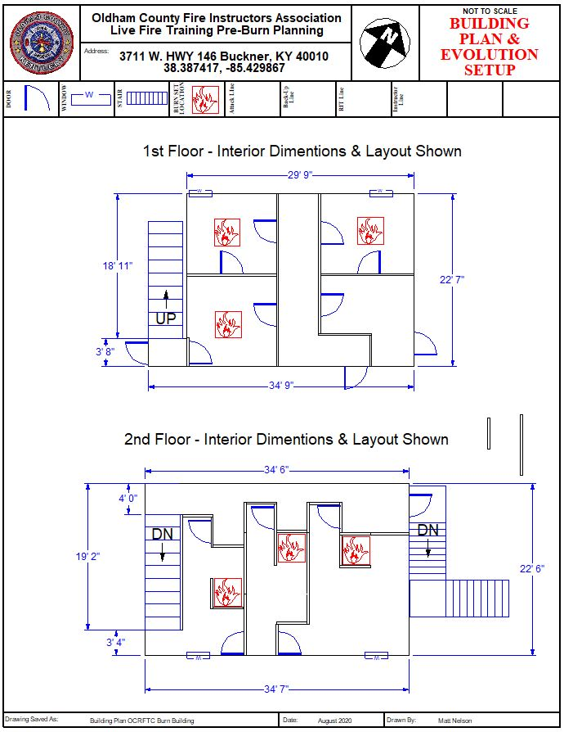
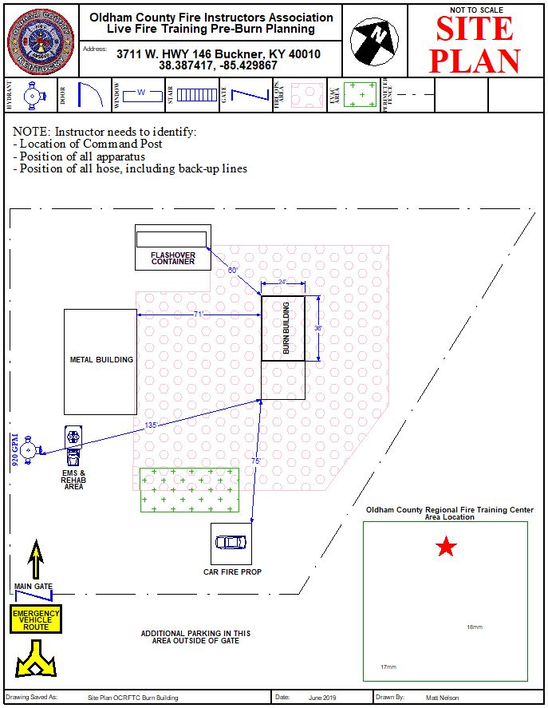
Evolution Objectives – Circle All That Apply or Fill In the Blank
Objective 1: Crew of two or more personnel will advance a charged 1 ¾” hose line, locate, confine, and extinguish a fire involving Class A materials.
Objective 2: Crew of two of more personnel will advance a charged 1 ¾” hose line, search, locate, and remove a training manikin victim from the fire building in proximity of fire location. Crew will also confine or extinguish the fire involving Class A materials.
Objective 3: Crew of two or more personnel will advance a charged 1 ¾” hose line, locate, confine, and extinguish a fire involving Class A materials, then perform hydraulic ventilation.
Objective 4: Crew of two or more personnel will advance a charged 1 ¾” charged hose line, locate, confine, and extinguish a fire involving Class A materials, perform hydraulic ventilation and overhaul the room.
Objective 5: Crew of two or more personnel will locate and assemble into one area all tools and equipment needed for RIT operations. Personnel will identify why RIT is necessary during emergency operations, the responsibilities of RIT, an appropriate fireground tasks they may carry out while assigned to RIT. Crews will utilize the County Wide RIT Policy for RIT operations.
Objective 6: Crew of two or more personnel will properly position and operate a positive or negative pressure ventilation operation that is coordinated with the fire attack team by the incident commander.
Objective 7: Crew of two or more personnel will use Air Monitors to sample the environment during overhaul operations and discuss safety concerns that are present during overhaul operations.
Objective 8: ___________________________________________________________________
______________________________________________________________________________
______________________________________________________________________________
_____________________________________________________________________________________

Information and forms found after this
page in the application
packet are to be completed and
kept for internal use only by the
fire department conducting live burn training.
These forms do NOT need to
be submitted with the
Application for Live Fire Training.

Training Structure Preparation

- Building inspected to ensure structural integrity visual inspection to be conducted before each burn by the instructor staff. A 5 year inspection certificate by a P.E. will be kept on file and maintained by OCFIA.
- All utilities disconnected N/A
- Highly combustible interior wall and ceiling coverings removed N/A
- All holes in walls and ceilings patched
- Materials of exceptional weight removed from above training areas (or areas sealed off from activity) N/A
- Precut ventilation opening of adequate size for each separate roof area N/A
- Windows checked and operated, opened, or closed as needed
- Building components checked and operates
- Stairways made safe with railings in place
- Chimney checked for stability N/A
- Fuel tanks and closed vessels removed or adequately vented N/A
- Unnecessary inside and outside debris removed N/A
- Porches and outside steps made safe
- Cisterns, wells, cesspools, and other ground openings fenced or filled N/A
- Hazards from toxic weeds, hives, and vermin eliminated
- Hazardous trees, brush, and surrounding vegetation removed
- Exposures such as buildings, trees, and utilities removed or protected
- All extraordinary exterior and interior hazards remedied
- Fire set with prepared class A materials only; NO FLAMMABLE OR COMBUSTIBLE LIQUIDS, NO CONTAMINATED MATERIALS

Pre-Burn Procedures
All burns shall be conducted in compliance with NFPA 1403

- All Participants briefed on the following:
  - Training structure layout and safety rules
  - Crew and instructor assignments
  - Building evacuation procedure
  - Evacuation signal (must be demonstrated)
- All hose lines must be:
  - Checked for sufficient size for the area of fire involvement
  - Charged and test flowed
  - Supervised by qualified instructors
  - Manned by an adequate number of personnel
- All necessary tools and equipment placed into position
- Participants must be checked for:
  - Approved full personal protective clothing
  - Approved self-contained breathing apparatus (SCBA)
  - Adequate self-contained breathing apparatus air volume
- Ensure all participants have protective ensemble and equipment properly donned
- All participants including instructors placed through incident rehabilitation for a baseline set of vitals
- List of instructors and assignments
- List of other participants
- Ensure property owner has signed acquired building release form N/A

Post-Burn Procedures

- Account for all personnel
- Overhaul remaining fires (if needed)
- If further training is to be conducted, building must be inspected for stability and hazards
- Conduct training critique
- Prepare records and reports, if required
- Conduct account of activities
- Document any usual conditions of events
- Document any injuries incurred and treatments rendered
- Document any changes or deteriorations of burned building
- Prepare student training records
- Prepare certificates of completion
- Release property to owner N/A

Responsibilities of Personnel

Instructor-In-Charge
- Plan and coordinate all training activities
- Monitor activities to ensure safe practices
- Inspect building integrity prior to each fire
- Assign instructors to:
  - Attack hose lines
  - Backup hose lines
  - Functional assignments
  - Teaching assignments
- Brief instructors on responsibilities of:
  - Accounting for assigned students/Assessing student performance
  - Clothing and equipment inspection
  - Monitoring safety
  - Achieving tactical and training objectives
- Assign coordinating personnel as needed
  - EMS
  - Communications
  - Water supply
  - Apparatus staging
  - Breathing apparatus
  - Incident rehabilitation
  - Public relations
- Ensure adherence to this standard by all persons within the training area
- No alcohol consumption at any training
- No persons under the influence of drugs or alcohol allowed to participate

Responsibilities of Personnel - Continued
Safety Officer
- Prevent unsafe acts
- Eliminate unsafe conditions
- Intervene and terminate unsafe acts
- Supervise additional safety personnel as needed
- Coordinate lighting of fires with instructor-in-charge
- Ensure compliance of participant’s personal protective equipment with applicable standards
  - Protective ensemble
  - Self-contained breathing apparatus
  - Personal alarm device
- Ensure that all participants are accounted for , both before and after each evolution
- No alcohol consumption at any training
- No persons under the influence of drugs of alcohol allowed to participate
Instructor
- Monitor and Supervise assigned students (No more than 5 per instructor)
- Inspect students’ protective ensemble and equipment
- Account for assigned students, both before and after evolutions
- No alcohol consumption at any training
- No persons under the influence of drugs or alcohol allowed to participate
Student
- Acquire prerequisite training
- Become familiar with building layout
- Wear full protective ensemble
- Obey all instructions and safety rules
- Provide documentation of prerequisite training, when from an outside agency
- No alcohol consumption at any training
- No persons under the influence of drugs or alcohol allowed to participate

Accountability Checklist

Incident Commander: ____________________________________________________________

Instructor In-charge: _____________________________________________________________

Safety Officer(s): _______________________________________________________________

Ignition Officer: ________________________________________________________________

Accountability Officer: __________________________________________________________

Engineer of Primary Engine: ______________________________________________________

Engineer on Secondary Engine: ____________________________________________________

Inside Instructors: _______________________________________________________________
_____________________________________________________________________________________

Rapid Intervention Team: ________________________________________________________
_____________________________________________________________________________
____________________________________________________________________________________

Incident Rehabilitation Officer: ___________________________________________________

Secondary Instructors: ___________________________________________________________
______________________________________________________________________________

Student Assignments

GROUP 1
1. Team Leader
2.
3.
4.
5.

GROUP 2
1. Team Leader
2.
3.
4.
5.

GROUP 3
1. Team Leader
2.
3.
4.
5.

GROUP 4
1. Team Leader
2.
3.
4.
5.

Student Assignments

GROUP 5
1. Team Leader
2.
3.
4.
5.

GROUP 6
1. Team Leader
2.
3.
4.
5.

GROUP 7
1. Team Leader
2.
3.
4.
5.

GROUP 8
1. Team Leader
2.
3.
4.
5.

Student Assignments

GROUP 9
1. Team Leader
2.
3.
4.
5.

GROUP 10
1. Team Leader
2.
3.
4.
5.

GROUP 11
1. Team Leader
2.
3.
4.
5.

GROUP 12
1. Team Leader
2.
3.
4.
5.

